VISVESVARAYA TECHNOLOGICAL UNIVERSITY
BELAGAVI-590018
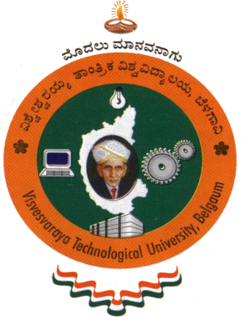
A Project Report On
“NeuroGraph: an Autism Spectrum Disorder
Detection method using functional MRI Data”
Submitted in the partial fulfillment of the requirement for the award of
Bachelor of Engineering in
Computer Science and Design
Submitted By
Disha K Gowda 1DT21CG015

Under the guidance of
Shalini Ranjan
Assistant Professor
Department of Computer Science Design
DSATM, Bangalore.



DEPARTMENT OF COMPUTER SCIENCE and DESIGN
DAYANANDA SAGAR ACADEMY OF TECHNOLOGY and MANAGEMENT
Udayapura, Kanakapura Main Road, Opp. Art of Living, Bengaluru-82

2024-2025

DAYANANDA SAGAR ACADEMY OF TECHNOLOGY AND MANAGEMENT
(Affiliated to Visvesvaraya Technological University, Belagavi and Approved by AICTE, New Delhi) (Accrediated by NAAC with A+ Grade)
Udayapura, Kanakapura Main Road, Opp. Art of Living, Bengaluru-560082

Department of Computer Science and Design
CERTIFICATE




This is to certify that the project report entitled “NeuroGraph: an Autism Spectrum Disorder Detection method using functional MRI Data” is a bonafide work carried out by Disha K Gowda (1DT21CG015) in the partial fulfillment of the requirement for the award of degree in Bachelor of Engineering in Computer Science and Design in DSATM for Visvesvaraya Technological University, Belagavi, for the year 2024-2025. It is certified that all corrections/suggestions indicated for the internal assessment have been incorporated in the report. This report has been approved as it satisfies the academic requirements in respect of project work prescribed for Bachelor of Engineering Degree.

------------------------- ------------------------- ---------------------------
Shalini Ranjan | Dr. G. Manjula | Dr. M. Ravishankar
Project Guide  Assistant Professor Dept of CSD | Professor & HOD  Dept of CSD  DSTAM, Bengaluru | Principal  DSATM, Bengaluru

External Viva
Name of Examiner | Signature with date
1. | 1.
2. | 2.

DAYANANDA SAGAR ACADEMY OF TECHNOLOGY AND MANAGEMENT
(Affiliated to Visvesvaraya Technological University, Belagavi and Approved by AICTE, New Delhi) (Accrediated by NAAC with A+ Grade)
Udayapura, Kanakapura Main Road, Opp. Art of Living, Bengaluru-560082

Department of Computer Science and Design
DECLARATION




I, the student of the final semester of Computer Science and Design, Dayananda Sagar Academy of Technology and Management, Bangalore, declare that the work entitled “NeuroGraph: an Autism Spectrum Disorder Detection method using functional MRI Data” has been completed under the guidance of Prof. Shalini Ranjan, Assistant Professor, Department of Computer Science and Design. This dissertation work is submitted to Visvesvaraya Technological University in partial fulfillment of the requirements for the award of the Degree of Bachelor of Engineering in Computer Science and Design during the academic year 2024 - 2025. Further, the matter embodied in the project report has not been submitted previously by anybody for the award of any degree or diploma to any university.

Project Associates:
Disha K Gowda 1DT21CG015

